**Introduction**:

In this Video Game Analysis, we have performed various analysis and Visualization based on the business need.

**Data Preparation:**

Before providing exploratory data analysis, we must determine which features are necessary for EDA. We must determine whether the dataset contains missing values, null values, etc. after choosing the necessary features. We replace any NULL values in the provided dataset with the necessary variables or values. The next step is to check the dataset to find out if there are any duplicate rows. There are no duplicates in the dataset as analyzed.

**Data Analysis and Visualization:**

After data preparation, we examine the information given. By comparing the Platform and the Count, the bar chart reveals that PS2 has the most counts.

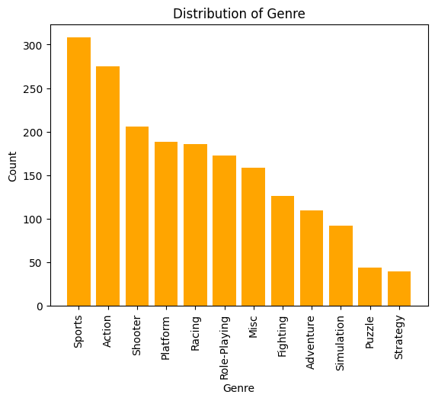

Next, by comparing Genre and Count, the bar chart shows Sports has the highest count.

Finally, by comparing the Publisher and Count, the bar chart shows that Electronics has maximum count.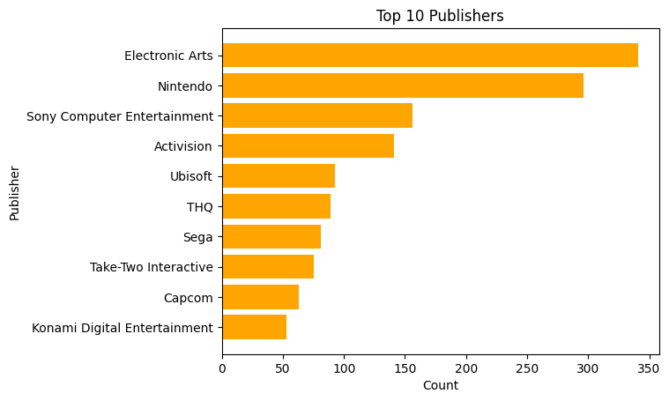

In conclusion, 1. PS2 has the highest number of count compared to other Platforms

2. Compared to others, Sports has the more number of counts

3. Electronic Arts has the maximum number of counts.